Inland Empire Health Plan
Functional Behavioral Assessment Report

Behavioral Health Treatment (BHT) service requirements per All Plan Letter (APL) 23-010.

In accordance with APL 23-010, BHT services provided under Medi-Cal for Members under the age of 21 must meet the following criteria:
- Medically Necessary
  - Services must be determined to be medically necessary under the Early and Periodic Screening, Diagnostic, and Treatment (EPSDT) standard, meaning they are necessary to correct or ameliorate a physical or behavioral health condition, as determined by a licensed physician, surgeon, or psychologist.
- Delivered Under a Managed Care Plan (MCP)-Approved Behavioral Treatment Plan
  - The treatment plan must be developed and supervised by a BHT provider who meets the qualifications outlined in California’s Medicaid State Plan.
  - The plan must be reviewed and approved by the Member’s MCP.
- Provided by Qualified Providers
  - Services must be delivered by a Qualified Autism Service (QAS) provider or a licensed provider acting within the scope of their licensure, as defined in the California Medicaid State Plan.
These requirements ensure that BHT services are clinically appropriate, evidence-based, and delivered by credentialed professionals in accordance with federal and state regulations.
- GENERAL INFORMATION:

First Name: |  | Last Name:
Birth Date: |  | IEHP Member ID#:
Present Address:
Parent/Guardian: |  | Phone:
Language: |  | Referral Date:
Report Date: |  | Assessor/Certification:
Assessor’s phone number:

- REASON FOR REFERRAL AND PRESENTING CONCERNS:
Write a brief description regarding the presenting concerns and why the Member is seeking services from your agency.

Name of Referring Provider, Credentials (if applicable): | Date Referred: | Reason for Referral:

- BEHAVIORS:
The behaviors and functional skills to be addressed are:

Non-Compliance | Physical Aggression | Verbal Aggression | Tantrums
Yelling/Screaming | Property Destruction | Self-injury | Elopement
Stereotypic Behavior | Smearing | PICA | Self-Help Skills
Functional Communication | Self-Direction | Social Skills | Hygiene
Toilet Training | Independent Living Skills | Safety Awareness | Food Selectivity
Other: _________________

- BACKGROUND INFORMATION:

  - Living Situation-
Within this section describe with whom the Member lives (including any custody/visitation orders, childcare arrangements).

Persons in Household and Relationship to IEHP Member:
Additional Information:

  - School Information-
Within this section list the Member’s school information: Grade Level, School placement (e.g., General Education Class, Specialized Academic Support, Autism Program, Mild/Moderate, Moderate/Severe, or Non-Public School), School name, School attendance days and hours, frequency and duration of related services provided by the school district (e.g., Occupational therapy, Speech Therapy, Physical Therapy, Adaptive Physical Education, Counseling, Nursing, Applied Behavior Analysis).

School Name: | Date of Last IEP:
Grade: | Did Provider Attend the Last IEP? Y/N
Teachers Name:
School Start and End Time:

School District:

School Placement:

School Services:

School-Based Services – Documentation Requirements
If school-based services are recommended, the following must be included in the Functional Behavioral Assessment (FBA):
- School Observation: A direct observation conducted in the school setting, with documentation of behaviors observed and environmental/contextual factors.
- School-Specific Goals: Clearly defined treatment goals that are designed to be implemented within the school environment, addressing behaviors that interfere with learning or social functioning in that setting.
- Service Hours: Clear indication of the number of hours to be conducted in the school setting, with rationale.
Note: Recommendations for school-based services must be individualized and supported by data gathered in the school context.
The MCP is required to ensure effective coordination with the Local Educational Agency (LEA), as necessary. This requirement is outlined in APL 23-010 issued by the California Department of Health Care Services (DHCS)

Include a copy of Member’s Individualized Education Plan (IEP) if services are provided in the school. IEP may be attached to the treatment plan.

Indicate which hours will be conducted in the school setting:
- These hours reflect the time that services or sessions will be delivered directly within the school environment

BHT (School Hours) | M | Tu | W | Th | F | Total
Session Time (e.g. 10am-12pm)

  - Health and Medical-
Within this section provide the Member’s psychological and medical diagnoses (include when and who provided the diagnoses). Describe the Member’s birth history, major illness, surgeries, hospitalizations, seizure history, allergies, hearing and vision screening results, vaccination, specialized diet or food consumption challenges, sleep difficulties. Include a list of medications and their relevance to behavior services.

Member’s last visit to the Primary Care Provider (PCP):
If the visit was more than one year ago, would the Member like assistance from IEHP in accessing care to their PCP?

  - Current Services and Activities-
Within this section list the weekly frequency and duration of all services funded by insurance (e.g., OT, ST, PT, Social Skills) and Inland Regional Center (e.g., Infant Stimulation, Respite, Adaptive Skills, Day Program). Additionally, include any weekly activities the Member participates in (e.g., Boy/Girl Scouts, baseball, basketball, soccer, dance, gymnastics, art therapy, etc.). Fill out box below:

All Services: | 1.  2.
Days and Times of Services: | 1.  2.
Additional Activities: | 1.  2.
Days and Times of Activities: | 1.  2.

  - Intervention History-
Within this section list discuss the Member’s intervention history. This includes services received during 0-3 (infant program), ABA services received through Regional Center or private insurance, social recreation/community integration adaptive skills training speech therapy, occupational therapy, and physical therapy. (List the weekly frequency and duration, the length of time the Member received the therapy and the provider/agency that provided the services.) Fill out box below:

All Services: | 1.  2.

  - Availability for BHT Services-
Within this section list the Member’s and Parents/Guardians availability to participate in the BHT services. Fill out box below:

BHT Availability | M | Tu | W | Th | F | Sat | Sun | Total
Session Time (e.g. 10am-12pm):

- MEMBER’S ENVIRONMENTAL ANALYSIS:

Availability and access to reinforcers: | Yes | No
Availability of developmental toys/materials: | Yes | No
Availability of visual schedules/timers: | Yes | No
Opportunities for activities throughout the day: | Yes | No
Opportunities for social interaction: | Yes | No
Will parent schedule allow for treatment involvement? | Yes | No
Appropriate space available for conducting sessions? | Yes | No
Environment conducive to QASP policy on cleanliness? | Yes | No
Level of noise/environmental distractions: | None | Fair | High
- DESCRIPTION OF ASSESSMENT PROCEDURES:
Procedures: | Date and Location: | Person Involved (Indicate Credentials):
Records Reviewed:
Clinical Interview:
1st Member Observation:
2nd Member Observation:
Brief Functional Analysis:

Stimulus Preference Assessments: | Date(s) Administered:
Free Operant Observations
Single Stimulus
Paired Stimulus
Multiple Stimulus with Replacement (MSW)
Multiple Stimulus without Replacement (MSWO)
Structured Interview (RAISD)
Checklist

Assessment Measures Administered: | Date(s) Administered:
Verbal Behavior Milestones Assessment and Placement Program (VB-MAPP)
Vineland Adaptive Behavior Scales, 2nd Edition
Adaptive Behavior Assessment System, 3rd Edition
Assessment of Functional Living Skills (AFLS)

Indirect Functional Analysis Tools Used: | Date(s) Administered:
Functional Assessment Screening Tool (FAST)
Motivation Assessment Scale (MAS)
Questions About Behavior Function (QABF)

  - Records reviewed included: Within this section of the report, include any records reviewed (e.g., Individual Program Plan (IPP), Psycho-Diagnostic Evaluation (PDE), Early Start Report, Functional Behavior Assessment, Intensive Intervention Progress Report, Individual Education Plan (IEP), etc.). Report title, report date and report author information is required for each document reviewed. Select from the following records and include additional, as applicable:

Records Reviewed: | Report Date: | Report Written By:
Individual Program Plan (IPP)
Psycho-Diagnostic Evaluation (PDE)
Individual Education Plan (IEP)
Additional documents:

Clinical Interview with Parent/Guardian- Within this section the assessor will narrate the date, time, location, and persons involved in the clinical interview. The assessor will write a summary of parental concerns (e.g., challenging behaviors and skill deficits).

*Please note: This does not meet criteria for direct Member observation. An FBA based solely on a clinical interview may be denied without strong clinical justification.

  - First Member Observation- Within this section the assessor will narrate the date, time, location, and people involved in the first observation of the Member. The assessor will briefly describe significant events (e.g., skill observations, direct observation of behavior occurrence) pertaining to the Member’s challenging behaviors.

Skill | Data Collected/Baseline | Location

*Please note: If data is not directly tested, a clear and clinically supported rationale must be provided. Failure to include this justification may result in denial of the assessment.

  - Second Member Observation- Within this section the assessor will narrate the date, time, location, and persons involved in the first observation of the Member. The assessor will briefly describe significant events (e.g., skill observations, direct observation of behavior occurrence) pertaining to the Member’s challenging behaviors.

  - Preference Assessment- Within this section the assessor will state the preference assessment administered to the Member during the assessment.

Preference Areas: | Potential Reinforcers:
Social
Sensory
Toys or Activities
Food

  - Limited Reinforcers- Within this section the assessor will list any reinforcement restrictions or limitations.

- ASSESSMENT MEAURES:
Verbal Behavior Milestones Assessment and Placement Program (VB-MAPP)
Milestones Scoring Form
(Insert page break)
VB-MAPP Barriers to Learning

(Insert page break)
Vineland Adaptive Behavior Scales, 2nd Edition

Date Administered: MM/DD/YYYY

Name of Interview: First name, last name, credentials

Name of Respondent: First name, last name, relationship

Assessment Summary:
Write a brief narrative about the results and include the following in a paragraph:
- If there are significant differences between what is reported by the respondent to your observations, note that tactfully
- Note the Adaptive Behavior Composite score from last year and any significant changes with the results since then
- Refer the reader to reference last year’s report for full Vineland scores

Domain | Standard  Score* | 95% Confidence  Interval** | Age  Equivalent*** | Adaptive  Level****
Communication
Receptive |  |  | 3 years, 5 months
Expressive
Daily Living Skills
Personal
Domestic
Community
Socialization
Interpersonal Relationships
Play and Leisure Time
Coping Skills
Motor Skills
Gross Motor
Fine Motor
Adaptive Behavior Composite

(Insert page break)

Assessment of Functional Living Skills (AFLS)
Basic Skills/Community Participation/Home Skills

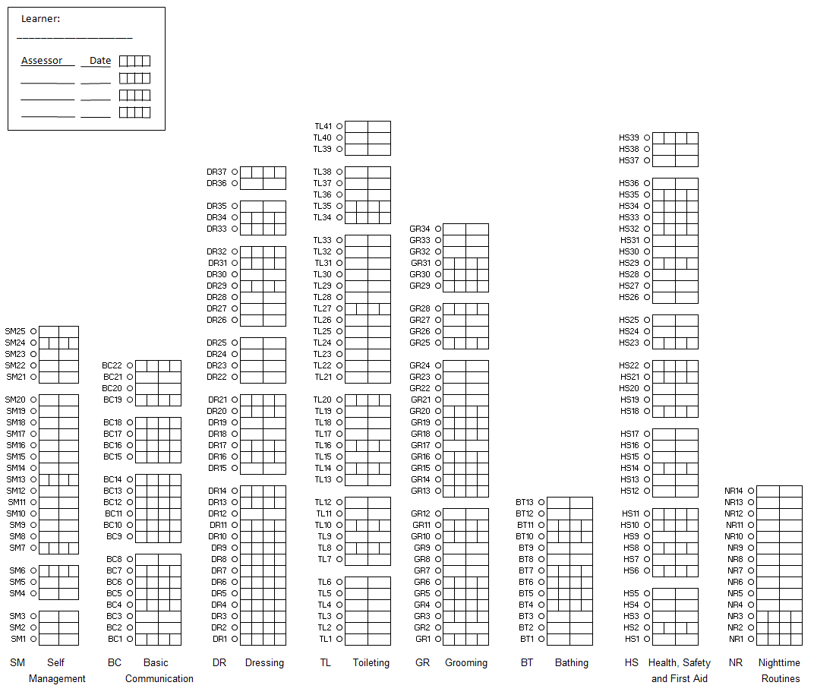

(Insert page break)

Adaptive Behavior Assessment System, Third Edition (ABAS-3)

Date Administered: MM/DD/YYYY

Name of Interview: First name, last name, credentials

Name of Respondent: First name, last name, relationship

Age: XX years, XX months

Age at Testing: XX years, XX months

Assessment Summary:
Write a brief narrative about the results and include the following in a paragraph:

Skill Area | Raw Score | Scaled Score | Description
Communication
Community Use
Functional Academics
Home Living
Health and Safety
Leisure
Self-Care
Self-Direction
Social
Work

(Insert page break)

- Target Behaviors

Behavior #1 (Insert Behavior Name)
Assessor will follow this behavior series for each target behavior identified.

- Descriptive Phase
  - Topography of behavior: Operational definition of the target behavior. The definition will be observable, measurable, and objective. (Based on this technological description all individuals will be able to easily recognize and record behavior.) Definition should include criteria regarding what is and is not counted as the target behavior (e.g., duration, severity, instances vs. episodes, etc.).
  - Onset/offset: Statement regarding when the behavior begins and ends.
  - Course of behavior: Describe whether or not the behavior occurs across persons, places, and times of the day. List any escalation patterns and/or cycles. Describe how the behavior typically subsides.
  - History and recent changes: Write a brief statement regarding the history of the behavior and any recent changes to the behavior.
  - Source: What social significance does the behavior serve (e.g., parental concern, observation)
  - Baseline data: Insert baseline data for target behavior.
    - Date collected:
    - Location:
    - Baseline:

* If data is not directly tested, a clear and clinically supported rationale must be provided. Failure to include this justification may result in denial of the assessment.

(Insert graph – align left)
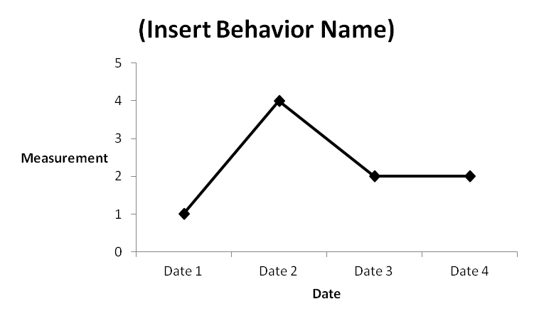
  - Functional Analysis Screening Tool (e.g., FAST, MAS, QABF): Write a brief description of the tool used (e.g., the functional assessment screening tool is a questionnaire presented to caregivers of an individual in order to identify a hypothesized function for a given target behavior. Questions asked to caregivers are presented in a random order and designed to assess whether the behavior occurs in the presence/ absence of a variety of environmental factors.
(Insert graph – align left)
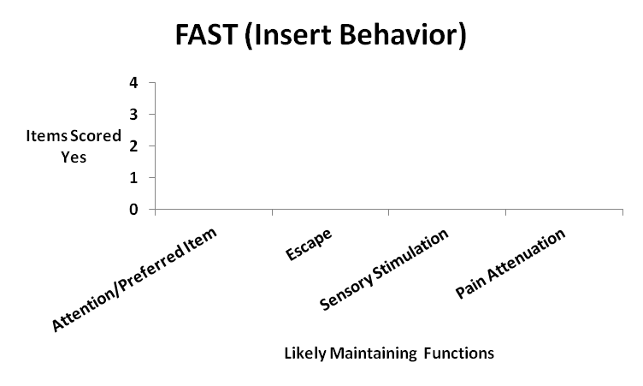

  - Antecedent Analysis: within this section the assessor will identify setting of events and triggering events for the target behavior. The assessor will summarize environmental events that preceded the target behavior.

(Insert graph – align left)
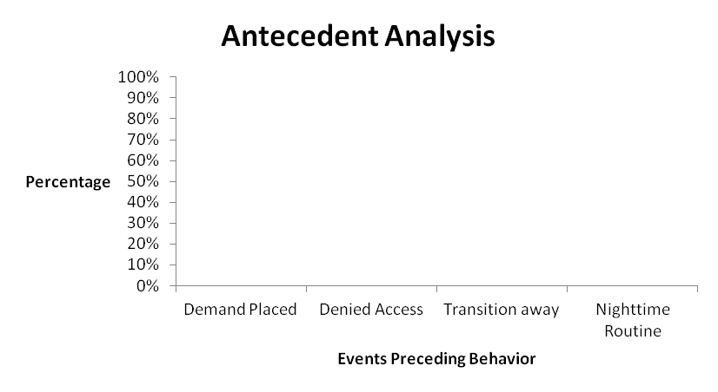

  - Consequence Analysis: within this section the assessor will identify environmental events that follow/followed the target behavior.
(Insert graph – align left)
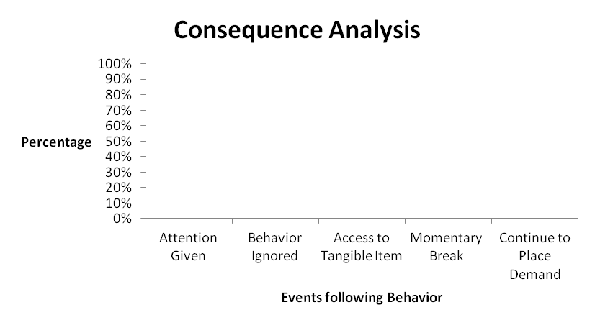
  - Analysis of Meaning/Hypotheses: Based on the information gathered from (Clinical Interview, Screening Tools, Direct Observation and Structured A-B-C Data collection, Antecedent and Consequence Analysis) the hypothesized function of Member’s (insert behavior) is (insert function or multiple functions).

- Verification Phase
  - Functional Assessment: (This section is optional.) Within this section describe the functional analysis procedures, testing conditions and the results. A graph is required for each testing condition.

- Program Goals

When data is not directly tested, a detailed and clinically supported rationale must be provided. Failure to include this justification may result in denial of the assessment. Additionally, treatment goals must align with the clinical recommendations and clearly demonstrate efficacy in addressing the Member’s identified needs.

- Behavior:

- Program Name: Title of program being targeted
Instrumental Goal: (By Date) Objective of the program (make sure this is measurable, objective, and specific)
Short term:
Intermediate:
Clinical Justification for Goal: (Include rationale of why goal is medically necessary or socially significant)
Data Collection: How data will be collected (e.g., first trial data, rate per hour, percentage of opportunities, partial interval recording)
Mastery Criteria: How you will measure mastery (e.g., 3 consecutive sessions of correct responding)
Generalization Criteria: How you will measure if the skill is generalized (e.g., Across 3 people, 3 settings, and 3 exemplars)
Baseline: Insert baseline data for target behavior.
    - Date collected:
    - Location:
    - Baseline:
* If data is not directly tested, a clear and clinically supported rationale must be provided. Failure to include this justification may result in denial of the assessment.

- Program Name: Title of program being targeted
Instrumental Goal: (By Date) Objective of the program (make sure this is measurable, objective, and specific)
Short term:
Intermediate:
Clinical Justification for Goal: (Include rationale of why goal is medically necessary or socially significant)
Data Collection: How data will be collected (e.g., first trial data, rate per hour, percentage of opportunities, partial interval recording)
Mastery Criteria: How you will measure mastery (e.g., 3 consecutive sessions of correct responding)
Generalization Criteria: How you will measure if the skill is generalized (e.g., Across 3 people, 3 settings, and 3 exemplars)
Baseline: Insert baseline data for target behavior.
    - Date collected:
    - Location:
    - Baseline:
* If data is not directly tested, a clear and clinically supported rationale must be provided. Failure to include this justification may result in denial of the assessment.

- Communication:

- Program Name: Title of program being targeted
Instrumental Goal: (By Date) Objective of the program (make sure this is measurable, objective, and specific)
Short term:
Intermediate:
Clinical Justification for Goal: (Include rationale of why goal is medically necessary or socially significant)
Data Collection: How data will be collected (e.g., first trial data, rate per hour, percentage of opportunities, partial interval recording)
Mastery Criteria: How you will measure mastery (e.g., 3 consecutive sessions of correct responding)
Generalization Criteria: How you will measure if the skill is generalized (e.g., Across 3 people, 3 settings, and 3 exemplars)
Baseline: Insert baseline data for target behavior.
    - Date collected:
    - Location:
    - Baseline:
    - * If data is not directly tested, a clear and clinically supported rationale must be provided. Failure to include this justification may result in denial of the assessment.

- Program Name: Title of program being targeted
Instrumental Goal: (By Date) Objective of the program (make sure this is measurable, objective, and specific)
Short term:
Intermediate:
Clinical Justification for Goal: (Include rationale of why goal is medically necessary or socially significant)
Data Collection: How data will be collected (e.g., first trial data, rate per hour, percentage of opportunities, partial interval recording)
Mastery Criteria: How you will measure mastery (e.g., 3 consecutive sessions of correct responding)
Generalization Criteria: How you will measure if the skill is generalized (e.g., Across 3 people, 3 settings, and 3 exemplars)
Baseline: Insert baseline data for target behavior.
    - Date collected:
    - Location:
    - Baseline:

* If data is not directly tested, a clear and clinically supported rationale must be provided. Failure to include this justification may result in denial of the assessment.

- Self-Help:

- Program Name: Title of program being targeted
Instrumental Goal: (By Date) Objective of the program (make sure this is measurable, objective, and specific)
Short term:
Intermediate:
Clinical Justification for Goal: (Include rationale of why goal is medically necessary or socially significant)
Data Collection: How data will be collected (e.g., first trial data, rate per hour, percentage of opportunities, partial interval recording)
Mastery Criteria: How you will measure mastery (e.g., 3 consecutive sessions of correct responding)
Generalization Criteria: How you will measure if the skill is generalized (e.g., Across 3 people, 3 settings, and 3 exemplars)
Baseline: Insert baseline data for target behavior.
    - Date collected:
    - Location:
    - Baseline:

* If data is not directly tested, a clear and clinically supported rationale must be provided. Failure to include this justification may result in denial of the assessment.

- Program Name: Title of program being targeted
Instrumental Goal: (By Date) Objective of the program (make sure this is measurable, objective, and specific)
Short term:
Intermediate:
Clinical Justification for Goal: (Include rationale of why goal is medically necessary or socially significant)
Data Collection: How data will be collected (e.g., first trial data, rate per hour, percentage of opportunities, partial interval recording)
Mastery Criteria: How you will measure mastery (e.g., 3 consecutive sessions of correct responding)
Generalization Criteria: How you will measure if the skill is generalized (e.g., Across 3 people, 3 settings, and 3 exemplars)
Baseline: Insert baseline data for target behavior.
    - Date collected:
    - Location:
    - Baseline:

* If data is not directly tested, a clear and clinically supported rationale must be provided. Failure to include this justification may result in denial of the assessment.

- Social Skills:

- Program Name: Title of program being targeted
Instrumental Goal: (By Date) Objective of the program (make sure this is measurable, objective, and specific)
Short term:
Intermediate:
Clinical Justification for Goal: (Include rationale of why goal is medically necessary or socially significant)
Data Collection: How data will be collected (e.g., first trial data, rate per hour, percentage of opportunities, partial interval recording)
Mastery Criteria: How you will measure mastery (e.g., 3 consecutive sessions of correct responding)
Generalization Criteria: How you will measure if the skill is generalized (e.g., Across 3 people, 3 settings, and 3 exemplars)
Baseline: Insert baseline data for target behavior.
    - Date collected:
    - Location:
    - Baseline:

* If data is not directly tested, a clear and clinically supported rationale must be provided. Failure to include this justification may result in denial of the assessment.

- Program Name: Title of program being targeted
Instrumental Goal: (By Date) Objective of the program (make sure this is measurable, objective, and specific)
Short term:
Intermediate:
Clinical Justification for Goal: (Include rationale of why goal is medically necessary or socially significant)
Data Collection: How data will be collected (e.g., first trial data, rate per hour, percentage of opportunities, partial interval recording)
Mastery Criteria: How you will measure mastery (e.g., 3 consecutive sessions of correct responding)
Generalization Criteria: How you will measure if the skill is generalized (e.g., Across 3 people, 3 settings, and 3 exemplars)
Baseline: Insert baseline data for target behavior.
    - Date collected:
    - Location:
    - Baseline:

* If data is not directly tested, a clear and clinically supported rationale must be provided. Failure to include this justification may result in denial of the assessment.

- School Goals (As applicable):

- Program Name: Title of program being targeted – (Introduced MM/DD/YYYY) (On Hold MM/DD/YYYY)
Instrumental Goal: (By Date) Objective of the program (make sure this is measurable, objective, and specific)
Data Collection: How data will be collected (e.g., first trial data, rate per hour, percentage of opportunities, partial interval recording)
Mastery Criteria: How you will measure mastery (e.g., 3 consecutive sessions of correct responding)
Generalization Criteria: How you will measure if the skill is generalized (e.g., Across 3 people, 3 settings, and 3 exemplars)
Baseline: Include a brief statement about the Member’s current skill level including a baseline measurement that EXACTLY matches the mastery criteria of the goal.
Progress: In Progress/Goal Met/On Hold/Modified/In Maintenance/Discontinued – Include specific information about progress made towards this goal, which may include: Each goal should include a brief narrative on mastered program targets, current program targets in acquisition, the prompting and fading procedures utilized during the reporting period, and the teaching plan for the upcoming reporting period.

(Insert graph – align left on the page)

Revised Goal (When Modifying/Revising a Goal, use the title Revised Goal with the revised goal and progress)
- Program Name: Title of program being targeted – (Introduced MM/DD/YYYY)
Instrumental Goal: (By Date) Objective of the program (make sure this is measurable, objective, and specific)
Clinical Justification for Revised Goal: (Include rationale of why goal is medically necessary or socially significant)
Data Collection: How data will be collected (e.g., first trial data, rate per hour, percentage of opportunities, partial interval recording)
Mastery Criteria: How you will measure mastery (e.g., 3 consecutive sessions of correct responding)
Generalization Criteria: How you will measure if the skill is generalized (e.g., Across 3 people, 3 settings, and 3 exemplars)
Baseline: Include a brief statement about the Member’s current skill level including a baseline measurement that EXACTLY matches the mastery criteria of the goal.
Progress: In Progress/Goal Met/On Hold/Modified/In Maintenance/Discontinued – Include specific information about progress made towards this goal, which may include: Each goal should include a brief narrative on mastered program targets, current program targets in acquisition, the prompting and fading procedures utilized during the reporting period, and the teaching plan for the upcoming reporting period.

(Insert graph – align left on the page)

New Goal(s) (When adding a new Goal within this section use the title New Goal(s) with the new goal)
- Program Name: Title of program being targeted
Instrumental Goal: (By Date) Objective of the program (make sure this is measurable, objective, and specific)
Short term:
Intermediate:
Clinical Justification for Goal: (Include rationale of why goal is medically necessary or socially significant)
Data Collection: How data will be collected (e.g., first trial data, rate per hour, percentage of opportunities, partial interval recording)
Mastery Criteria: How you will measure mastery (e.g., 3 consecutive sessions of correct responding)
Generalization Criteria: How you will measure if the skill is generalized (e.g., Across 3 people, 3 settings, and 3 exemplars)
Baseline: Insert baseline data for target behavior.
    - Date collected:
    - Location:
    - Baseline:

* If data is not directly tested, a clear and clinically supported rationale must be provided. Failure to include this justification may result in denial of the assessment.

- Behavior Intervention Plan

Target Behavior Name:
Behavior Reduction Goal:
Definition of Behavior:
Function of Behavior:

Baseline and Date of Baseline:
Proactive Strategies:
Reactive Strategies:
Replacement Behavior(s):

* When data is not directly tested, a detailed and clinically supported rationale must be provided. Failure to include this justification may result in denial of the assessment. Additionally, treatment goals must align with the clinical recommendations and clearly demonstrate efficacy in addressing the Member’s identified needs.

Safety Procedure/Crisis Plan-
Please describe the safety procedures in place to protect the Member and others during the following situations:
- Crisis Situation(s)
- Extinction Burst(s)
- Behavioral Escalation(s)
Include the following details:
- Specific strategies used to ensure safety during these events
- Any individualized instructions or precautions based on the Member’s needs
- Techniques or protocols derived from the QASP’s adopted Crisis Prevention Training Program (e.g., Nonviolent Crisis Intervention, Safety-Care Behavioral Safety, Professional Crisis Management, or Professional Assault Crisis Training)
- Any restrictions, modifications, or contraindications to standard procedures
Note: All interventions must align with the Member’s behavior support plan and be implemented by trained providers only.

- Teaching Intervention Strategies- Within this section list all teaching procedures and methodologies used to the teach skill deficits and replacement behaviors. Include strategies on generalization, maintenance, thinning schedules of reinforcement, transition to natural mediators, and relapse prevention.

  - (Insert Teaching Approach/Strategy/Procedure)- Provide a description of the research and evidence-based teaching approach. Additionally, provide instructions for implementation.

- Family Involvement: Within this section of the report provider will outline parent involvement and participation within the therapy session. Provider will include a statement on the expected level of participation as outlined within the BHT IEHP Policy. Provider will outline the parent training and education approach for teaching the parent goals. Providers will include a plan on how the provider will address parental involvement within therapy sessions. Parent education goals will be listed below. Parent Participation is not an educational goal; it is an expectation. A Parent should have AT LEAST 2 Parent Education Goals.

- Parent Education:

- Parent Goal Domain: Title of Domain being targeted
Instrumental Goal: Objective of the program (make sure this is measurable, objective, and specific) include data collection procedure and mastery criteria.
Baseline: Insert baseline data for target behavior.
    - Date collected:
    - Location:
    - Baseline:

* If data is not directly tested, a clear and clinically supported rationale must be provided. Failure to include this justification may result in denial of the assessment.

- Parent Goal Domain: Title of Domain being targeted
Instrumental Goal: Objective of the program (make sure this is measurable, objective, and specific) include data collection procedure and mastery criteria.
Baseline: Insert baseline data for target behavior.
    - Date collected:
    - Location:
    - Baseline:

* If data is not directly tested, a clear and clinically supported rationale must be provided. Failure to include this justification may result in denial of the assessment.

Location of Service:
Include a description of where services will take place. Providers may not provide services in the school setting, day care, or other locations in which parent or caregiver is not present, unless prior authorization is given by the health plan.
Clinic-Based Services – Clinical Rationale Requirement
When recommending clinic-based services, providers must include a clear clinical rationale. The following criteria must be met:
- Home Environment Justification: The home setting must be documented as not conducive to effective therapy (e.g., due to safety concerns, lack of caregiver availability, or environmental distractions), or
- Socialization Goals: There must be a documented clinical need for peer interaction or structured social opportunities that cannot be met in the home setting.
Note: Age alone is not a valid justification for recommending clinic-based services.
Coordination of Care:

This section is a required component of the client’s service plan and is essential for ensuring integrated, person-centered care. Care coordination includes ongoing collaboration with all relevant parties involved in the client’s care. Coordination includes, but is not limited to:

- Guardian(s):
  - Participation in treatment planning meetings
  - Regular updates on progress and behavior
  - Coordination of home-based strategies to reinforce treatment goals
- School Personnel:
  - Communication with teachers, counselors, and administrators
  - Alignment of behavioral interventions with academic goals
  - Participation in IEP or 504 Plan meetings, as applicable
- State Disability Programs:
  - Coordination with Regional Center or state-funded services
  - Assistance with accessing additional supports such as respite care, adaptive equipment, or specialized therapies
  - Ensuring documentation meets eligibility and reporting standards
- Other Programs and Institutions (as applicable):
  - Collaboration with mental health providers, pediatricians, or specialists
  - Integration with after-school programs or community-based services
  - Sharing of relevant data and reports (with consent) to support continuity of care
All coordination efforts are reviewed regularly to ensure alignment with treatment goals and regulatory requirements.

Discharge, Transition and Exit Plans:
- Exit Plan (formerly Discharge/Graduation)

Include the following information:

Exit Plan Components:
- Anticipated Discharge Date:
  - [Insert projected date based on progress and treatment trajectory]
- Graduation Criteria:
  - A minimum of [insert %] of treatment goals must be met (e.g., 80%)
  - Sustained functional improvements across settings (home, school, community)
  - No longer meeting medical necessity under EPSDT, as determined by a licensed clinician
- Additional Criteria (as applicable):
  - Members and caregiver demonstrate understanding and ability to implement strategies independently
  - Risk factors (e.g., safety concerns, crisis behaviors) have been addressed or mitigated
  - Members have been successfully linked to ongoing supports or community resources
- Transition Planning:
  - Referrals to appropriate services (e.g., school-based supports, Regional Center, outpatient therapy)
  - Coordination with medical, educational, and community providers
  - Development of a follow-up plan to monitor post-discharge stability
- Caregiver and School Involvement:
  - Final team meeting to review progress and finalize exit plan
  - Provision of written strategies and resources for continued support
- Documentation:
  - Exit Plan shared with all relevant parties (with consent)

- Recommendations: Within this section provide a summary of the clinical recommendations for the Member. This should include the rationale for MEDICALLY NECESSARY BHT. The rate of supervision provided by the QAS Professional and/or QAS Provider to the QAS Paraprofessionals will be based on a ratio of 2 hours of supervision service per every 10 hours of direct service authorized, unless the case calls for increased supervision as agreed by QAS Provider and IEHP Health Plan. Providers requesting additional supervision beyond standard ratios and guidelines will need to include clinical justification on the need for enhanced supervision. Providers must only include the hours to be utilized by the Member in the request. Include the requested units and visits below:

Clinical Recommendations
CPT | Description | Units Requested
H2019 | Therapeutic Behavioral Services, per 15 minutes
H0032 | Mental Health Service Plan Development by Non-Physician, per 15 minutes (Mid-Tier Supervision by Non-certified/non-licensed Masters, BCaBA, BA enrolled in BCBA Program)
H0032-HO | Mental Health Service Plan Development by Non-Physician, per 15 minutes (Top-Tier Supervision by BCBA/LMFT/LCSW)
H0032-HP | Mental Health Service Plan Development by Non-Physician, per 15 minutes (Top-Tier Supervision by BCBA-D/Ph.D.)
S5111 | Home Care Training, Family; per visit  (By BCBA, BCaBA, Midlevel staff) | *Visits only
H2014 | Skills Training and Development, per 15 minutes  (By BCBA, BCaBA, Midlevel staff)

Report completed by: The Health plan requires the treatment plan to be developed by a BCBA per APL 23-010


_____________________________________
Name and Credentials : Date:
Title:
Agency Name:

